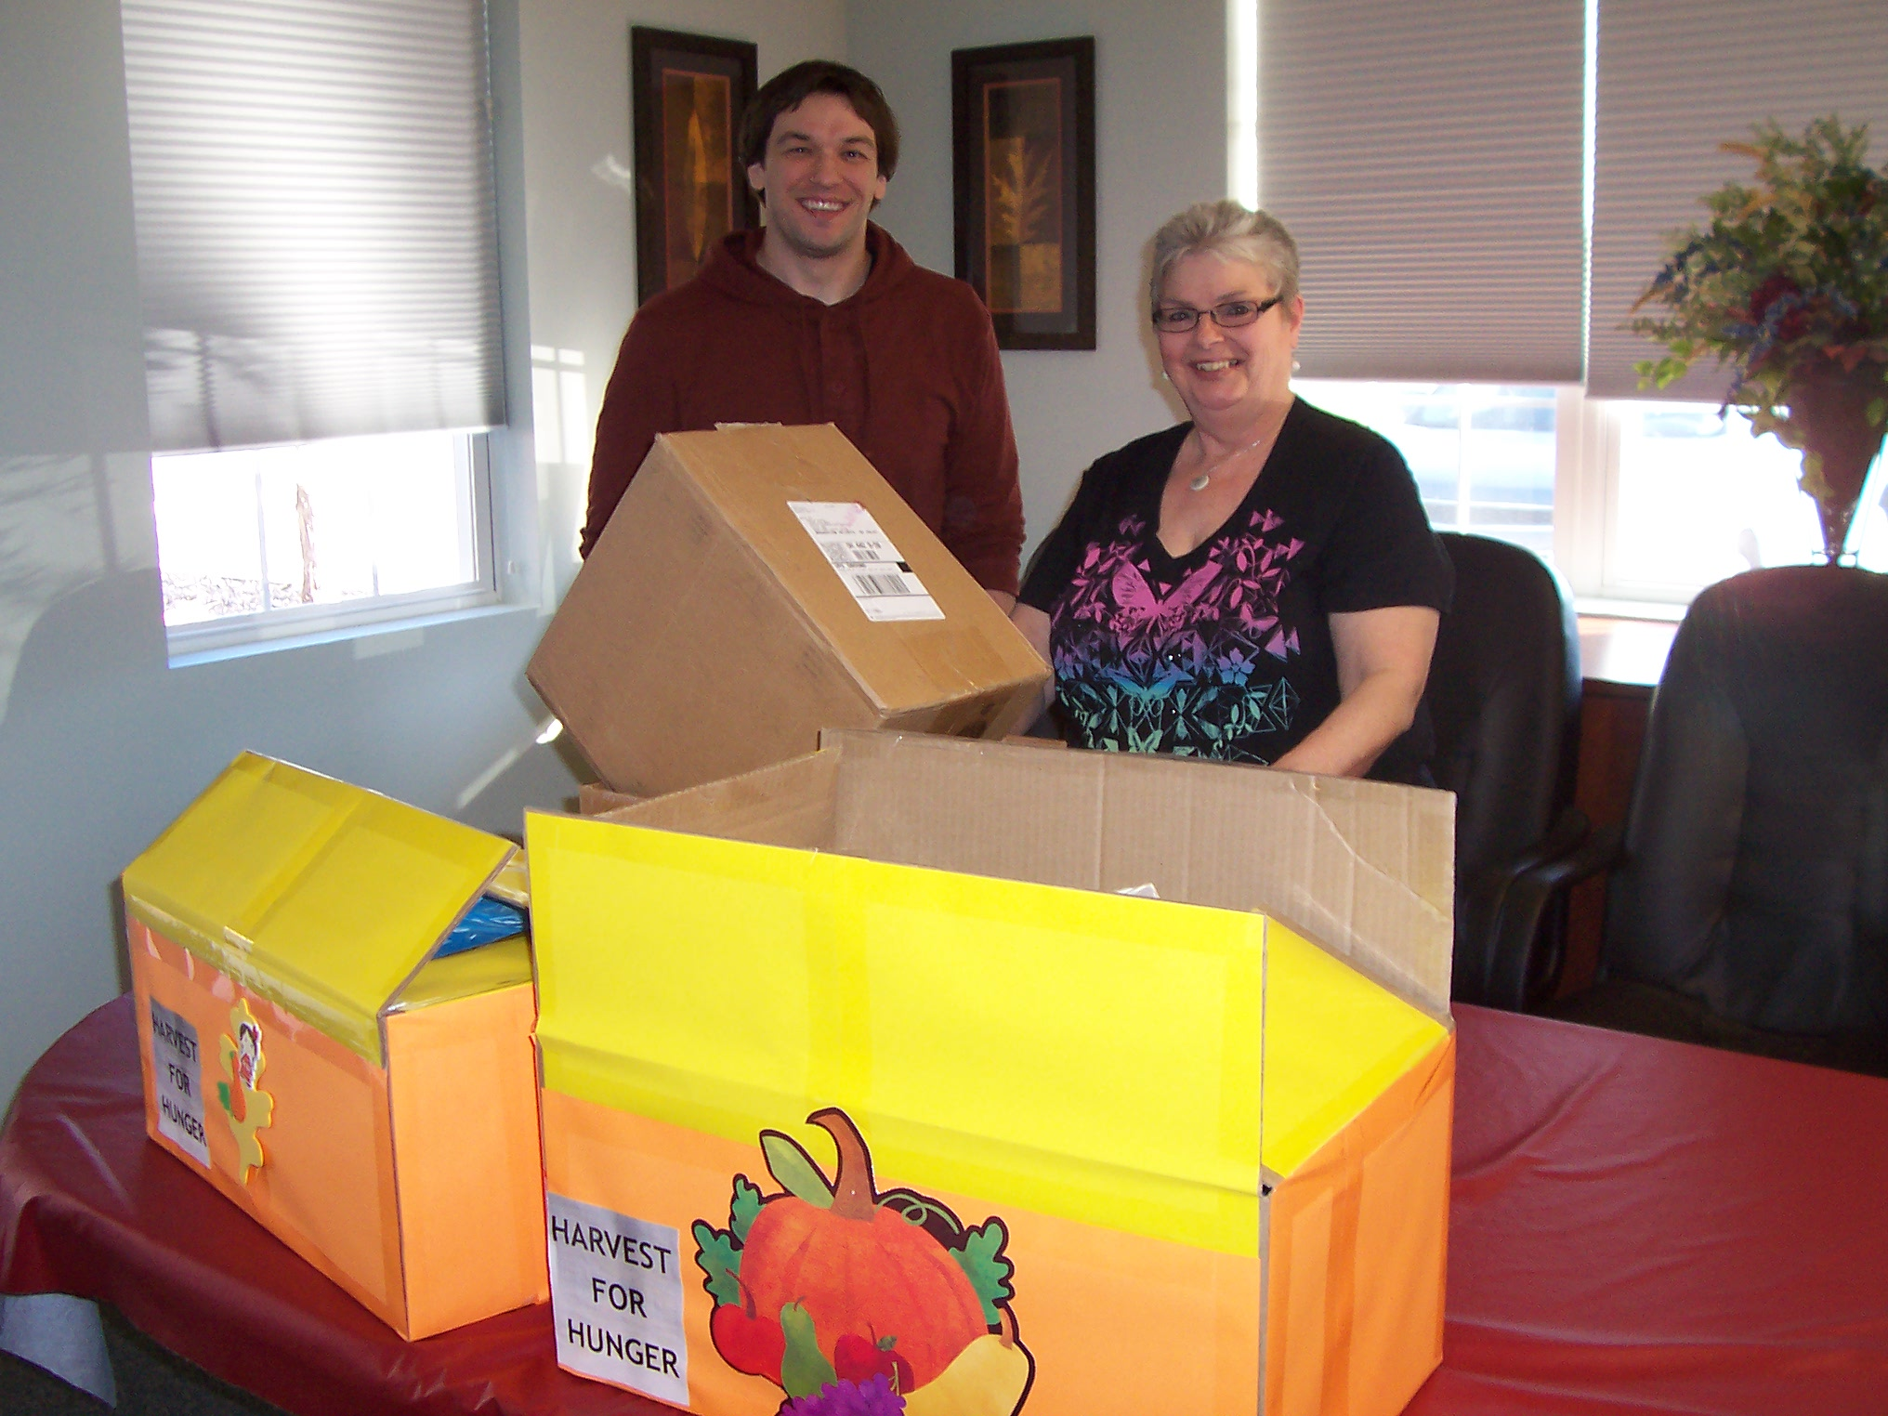

Cleveland, Ohio November 2012

Mutual Shareholder Services donates money and food to the Cleveland Food Bank for the Thanksgiving Holiday. After seeing an article for the “Harvest for Hunger” stating Hunger is closer than you think, but so is the Solution the employees of MSS wanted to be part of the solution and began giving donations to make meals available to hungry men, women, and children in the Cleveland area.

